EXPT NO: 4 | TRANSFER LEARNING USING PRE-TRAINED VISION MODELS FOR IMAGE RECOGNITION
DATE:

PRE-LAB QUESTIONS (PROVIDE BRIEF ANSWERS TO THE FOLLOWING QUESTIONS)
- What is transfer learning in deep learning?

Transfer learning is a technique in which a pre-trained model is reused for a new task. The model has already learned useful features from a large dataset. These learned features are applied to a new image-recognition problem. This reduces training time and computational requirements. It is especially useful when the new dataset is small.

- What are the advantages of using pre-trained models over training from scratch?

Pre-trained models reduce training time and computational cost. They require less data to achieve good performance. They already contain useful features learned from large datasets. They can provide better accuracy compared with models trained from scratch. They can also be easily adapted to new classification tasks.

- What is the role of fine-tuning in transfer learning?

Fine-tuning is used to adapt a pre-trained model to a new dataset. Some layers of the model are initially kept frozen. Selected layers are then trained using the new dataset. This allows the model to learn task-specific features. Fine-tuning can improve the accuracy of the final model.

- Name any three popular pre-trained computer vision models.

Three popular pre-trained computer vision models are ResNet-50, AlexNet, and VGG. These models are trained on large image datasets. They have learned useful features for image recognition. Their trained layers can be reused for new tasks. They are commonly used in transfer-learning applications.

- What is the purpose of Hugging Face and how is it useful in deep learning?

Hugging Face provides ready-to-use pre-trained deep-learning models. It makes loading and experimenting with vision models easier. These models can be used for tasks such as image classification. It also allows different models and their predictions to be compared. Thus, it simplifies experimentation with pre-trained models.
AIM
To implement transfer learning using pre-trained vision models for image recognition and evaluate their performance on real-world image datasets.

SOFTWARE REQUIREMENTS
- Python
- TensorFlow/Keras or PyTorch
- Google Colab
- Hugging Face Transformers
- Kaggle Dataset
- Matplotlib
- GitHub

OBJECTIVES
Students will be able to:
- Understand the concept of transfer learning.
- Apply pre-trained vision models for image recognition.
- Fine-tune models such as ResNet or AlexNet.
- Utilize Kaggle datasets and Hugging Face vision models.
- Compare transfer learning performance with custom CNN models.

Task A: DATASET PREPARATION
Perform the following tasks:
- Download an image dataset from Kaggle.
- Load and preprocess the images.
- Split the dataset into training, validation, and testing sets.

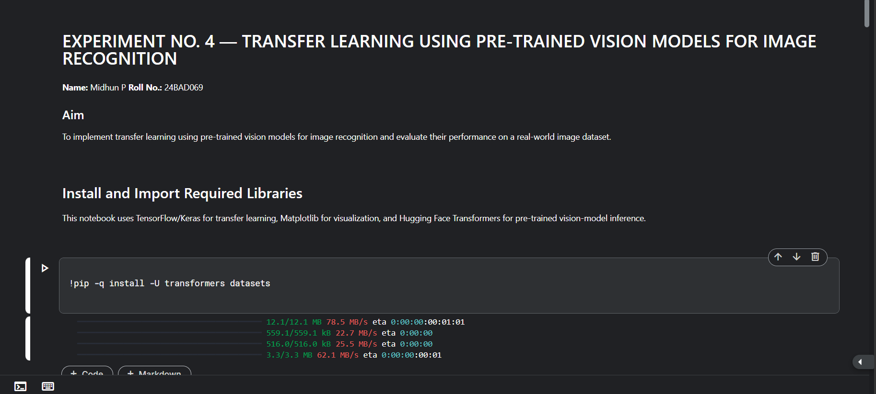

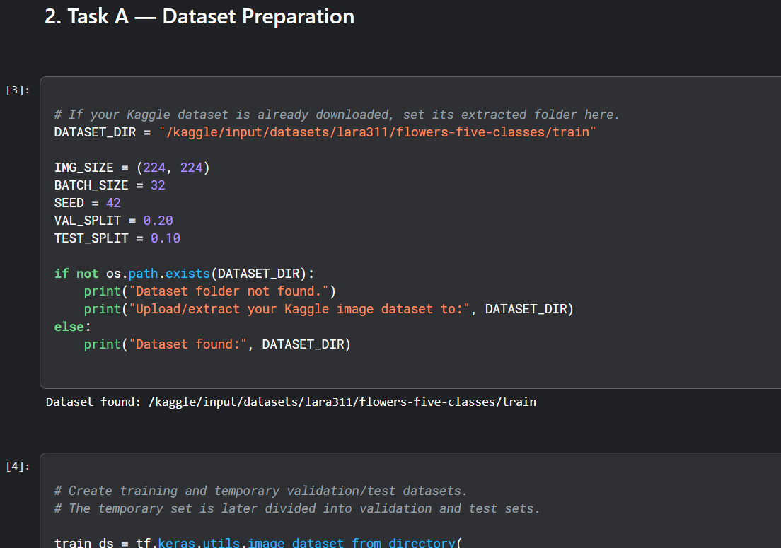
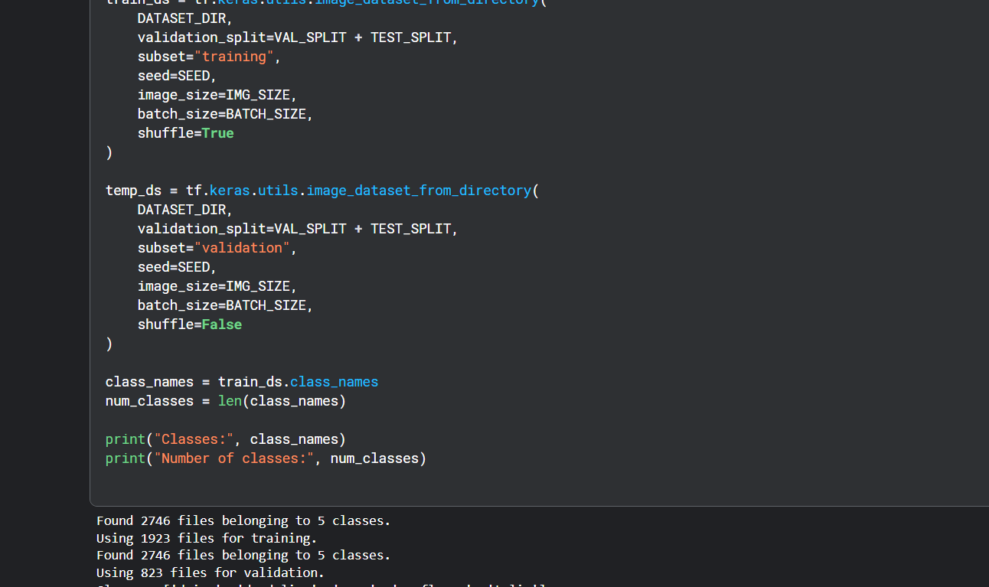
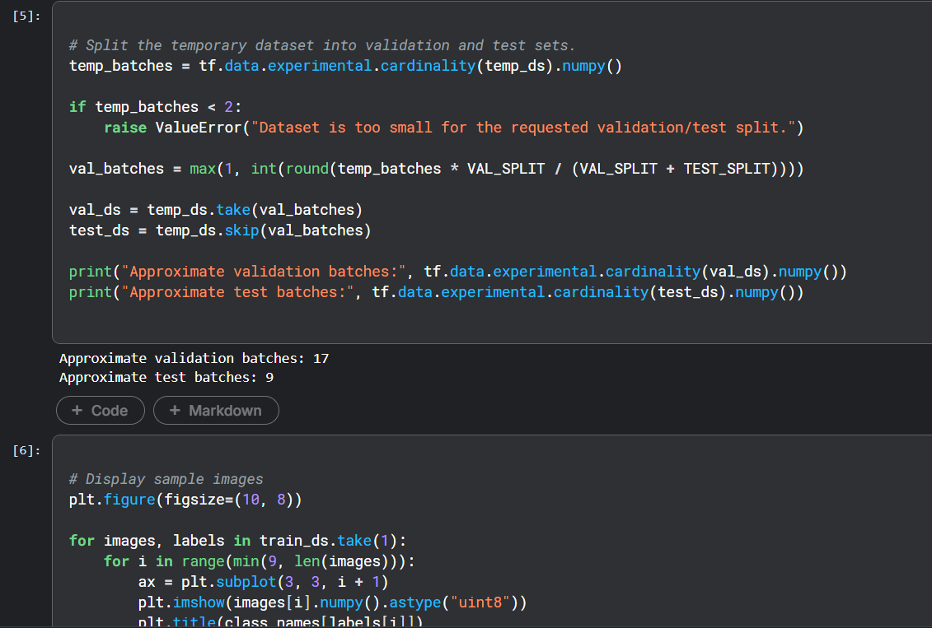
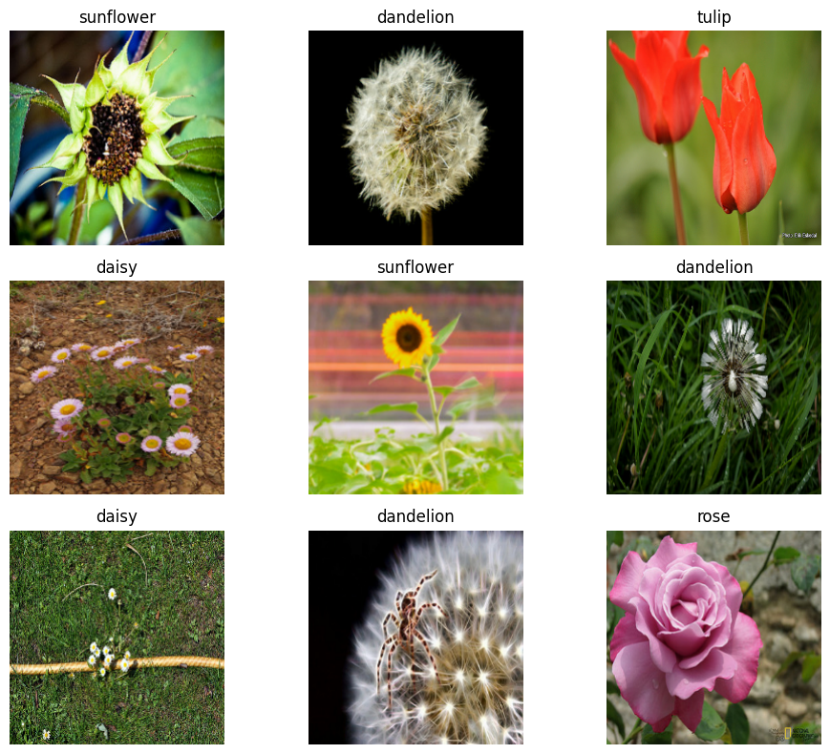

Task B: IMPLEMENTING TRANSFER LEARNING
Load a pre-trained model such as:
- ResNet-50
- AlexNet
Replace the final classification layer according to the dataset classes.
Freeze the feature extraction layers.
Compile the model.

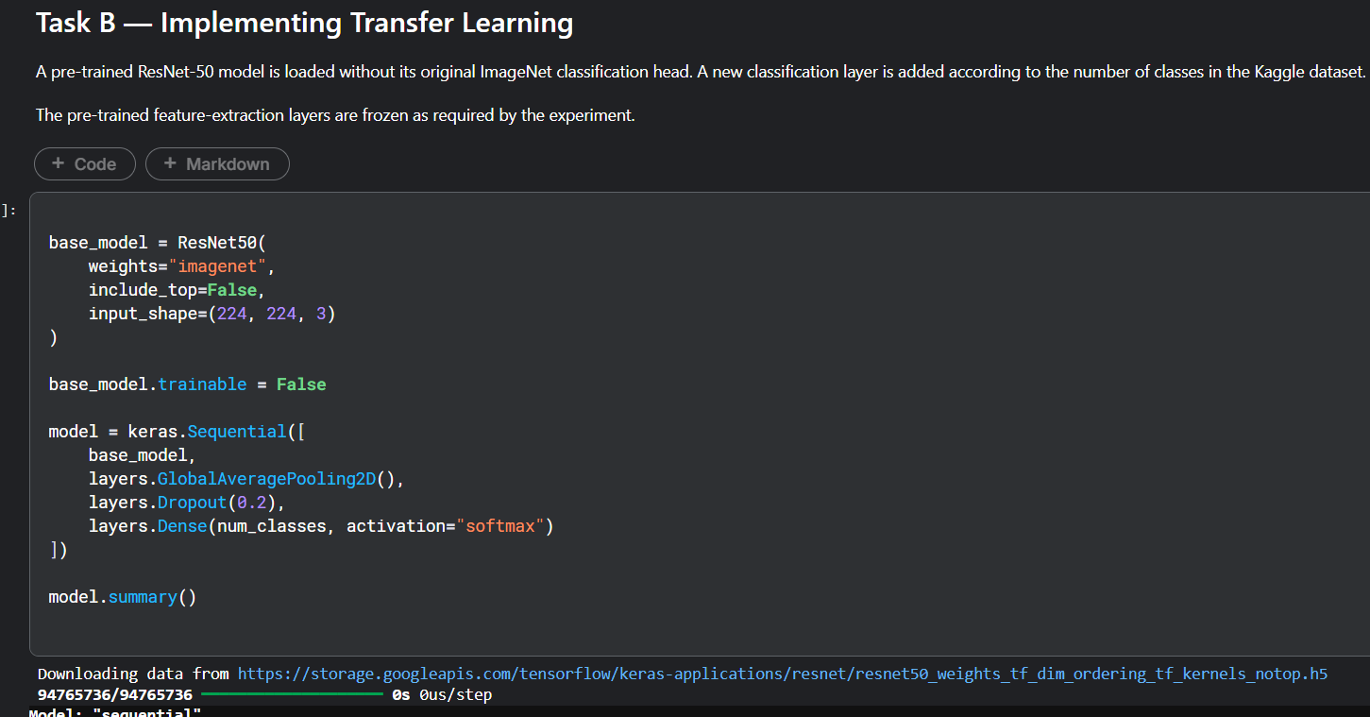
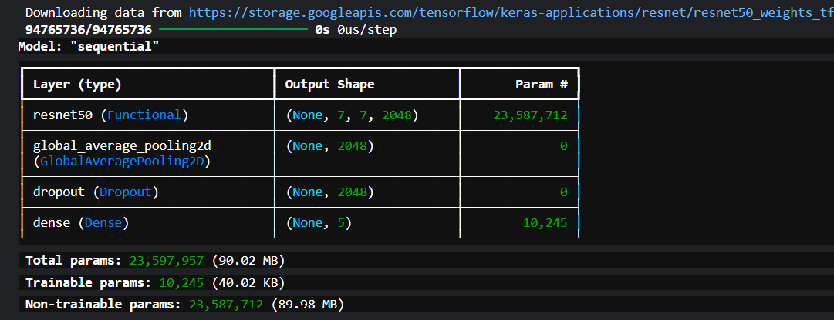
Task C: MODEL TRAINING AND PERFORMANCE EVALUATION
Train the transfer learning model.
Record:
- Training accuracy
- Validation accuracy
- Training loss
- Validation loss
- Test accuracy
Visualize:
- Accuracy vs Epoch
- Loss vs Epoch

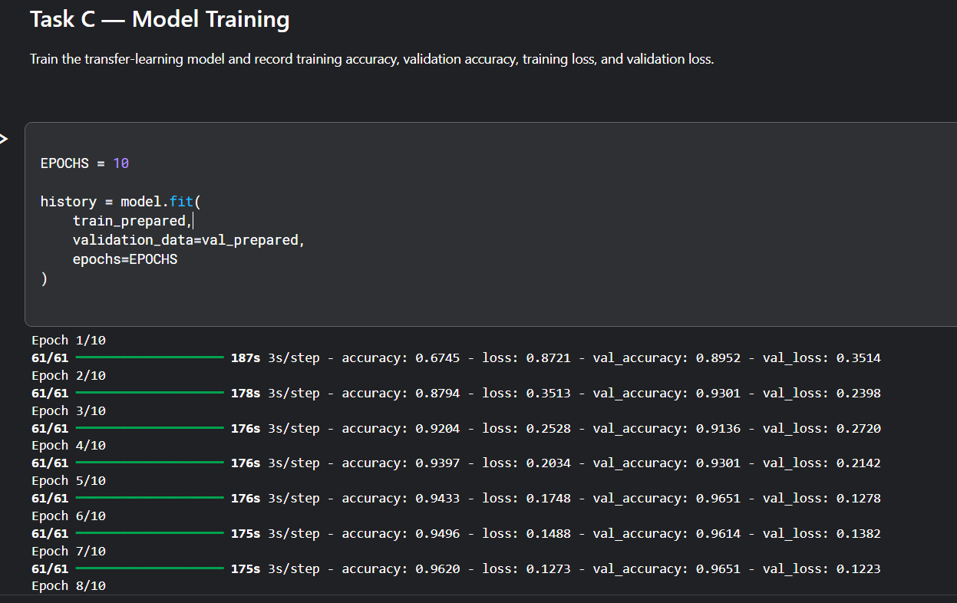

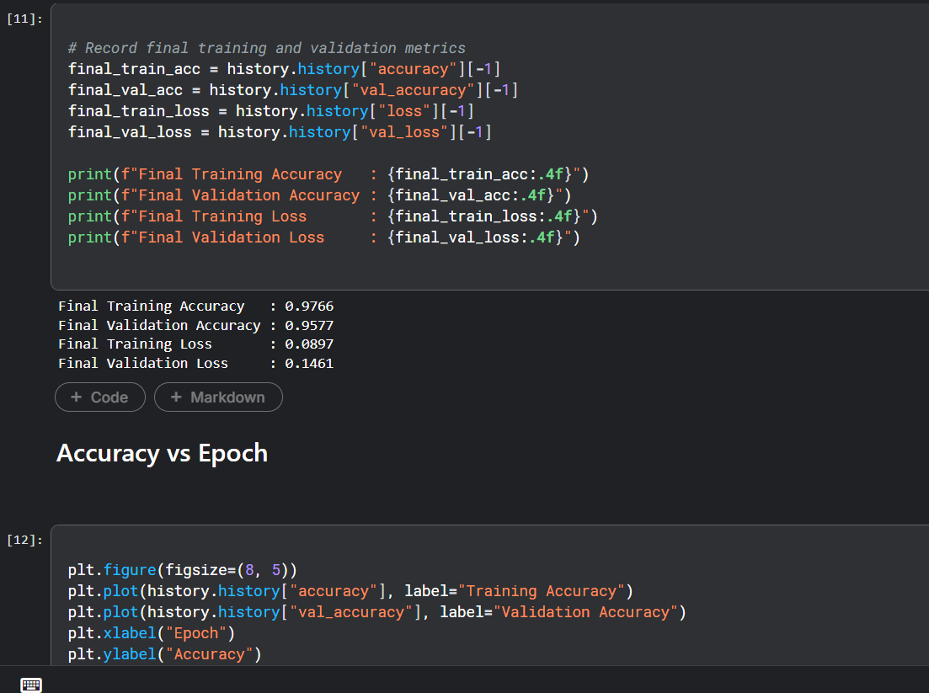
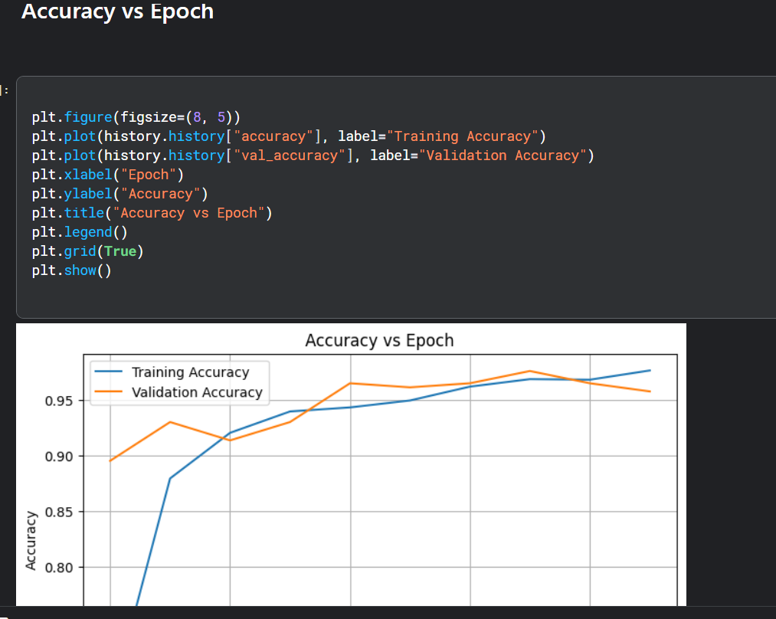

Task D: USING HUGGING FACE PRE-TRAINED MODELS
Perform the following tasks:
- Load a pre-trained vision model from Hugging Face.
- Perform image classification on sample images.
- Compare predictions with the transfer learning model.
- Document observations and upload the notebook to GitHub.

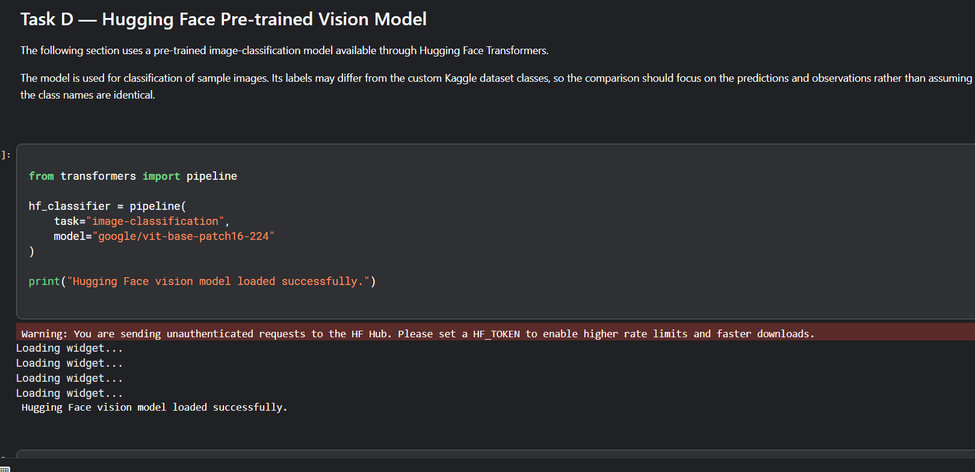
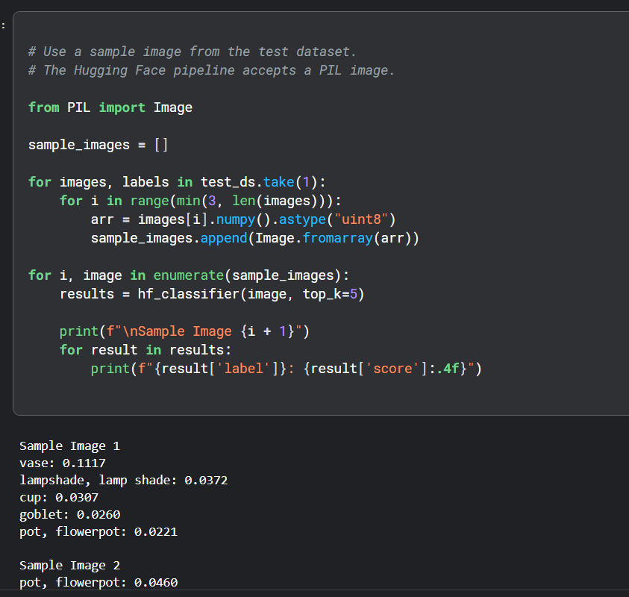
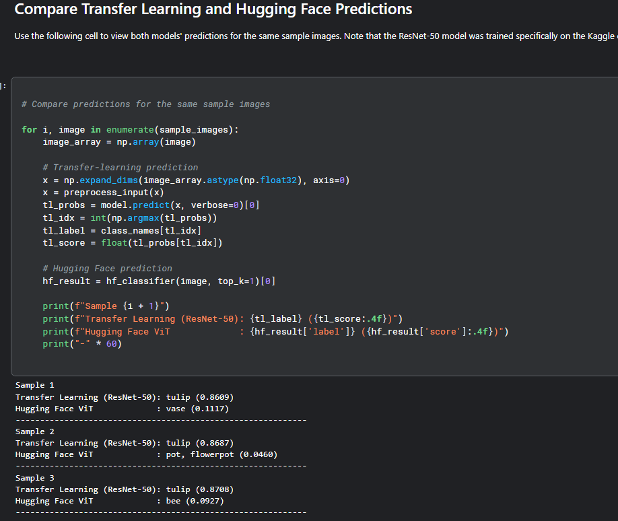

(CODE: CONATAINS STUDENT ROLL NOS
SCREENSHOT OF CODE
SCREENSHOT OF OUTPUT)

POST-LAB QUESTIONS (PROVIDE BRIEF ANSWERS TO THE FOLLOWING QUESTIONS)
- What are the advantages of transfer learning compared to training a CNN from scratch?

Transfer learning reduces training time and computational requirements. It works effectively even with smaller datasets. The pre-trained model already contains useful learned image features. It can achieve good accuracy with fewer training epochs. Therefore, it is more efficient than training a CNN completely from scratch.

- Why are pre-trained models able to achieve higher accuracy with fewer training epochs?

Pre-trained models have already learned important image features from large datasets. These features include useful patterns, shapes, and structures. Therefore, the model does not need to learn all features from the beginning. Only task-specific features need to be learned during training. This helps the model achieve good accuracy in fewer epochs.

- Compare the performance of the transfer learning model with the CNN implemented in the previous experiment.

The transfer learning model generally requires less training time than a CNN trained from scratch. It can achieve better accuracy with fewer training epochs. This is because the pre-trained model already has useful learned features. A custom CNN needs to learn these features from the available dataset. The exact performance depends on the results obtained in the experiment.

- What is the purpose of freezing layers during transfer learning?

Freezing layers prevents the pre-trained features from being changed during initial training. It preserves the useful features learned from the original dataset. It also reduces the number of parameters that need to be trained. This makes the training process faster and more stable. Usually, the final classification layers are trained first.

- How can Hugging Face simplify the deployment and experimentation of vision models?

Hugging Face provides ready-to-use pre-trained vision models. These models can be loaded without training them from the beginning. It makes image-classification experimentation easier and faster. Different models can be tested and their predictions can be compared. Therefore, Hugging Face simplifies the development and evaluation of vision applications.

ASSESSMENT
Description | Max Marks | Marks Awarded
Pre Lab Exercise | 5
In Lab Exercise | 10
Post Lab Exercise | 5
Viva | 10
Total | 30
Faculty Signature

